**MetaMask and Insula:**

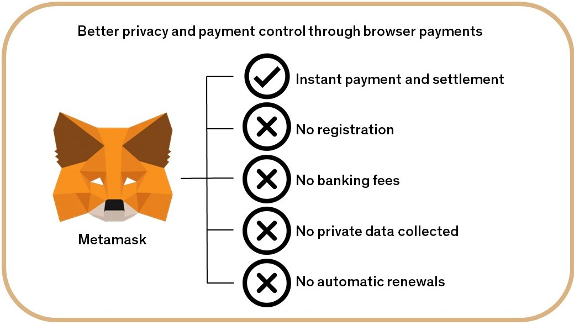

If you have an interest in **cryptocurrencies**, your must-have item is a **cryptocurrency** **wallet**. For those targeting [Ethereum](https://icoholder.com/blog/best-ethereum-exchange/) and ERC-20 tokens, one of the top option is **MetaMask**.

[**MetaMask**](https://metamask.io/) is an online crypto wallet.

The wallet has become a favorite for **crypto enthusiasts** because it does not simply **store** the **digital coins**, but further allows users to **interact** with [smart contracts](https://www.bitdegree.org/tutorials/what-is-a-smart-contract/) and [decentralized applications (DApps)](https://www.coindesk.com/information/what-is-a-decentralized-application-dapp/).

In order to be able to **connect** to **Insula applications** you need a **MetaMask** Wallet **installed**.

In order to be able to **invest** in **Insula applications** you need a **MetaMask** Wallet **installed** with a **positive** Ethereum (ETH balance).

What can you do with MetaMask:

**a - *Buy, store and send Insula tokens globally:***

Available as a **browser extension** and as a **mobile app**, **MetaMask** equips you with a **key vault**, **secure login**, and **token wallet**—everything you need to **manage** your **Insula digital assets**.

**MetaMask** allows you to **custody** **your** **own assets** by storing your **private keys** yourself rather than relying on a **centralized** intermediary.

***b - Explore Insula blockchain apps:***

## **MetaMask** provides the **simplest** yet **most secure** way to **connect** to Insula’s blockchain-based applications. You are always in **control** when **interacting** on the new **decentralized web**.

## ***c - Own your investor data:***

**MetaMask** generates passwords and keys on your device, so only **you** have access to your Insula **accounts and data**. You always choose what to share and what to keep **private**.